Symbolic Interactionism

A psychological theory that attempts to explain how individuals choose how they will act based on their perception.

Areas of main focus: family and ______________________________

What are three main principles of this theory?
1) ‘Me’ represents tall, male, _____________________

‘I’ represents shy, excellent soccer player, ____________________

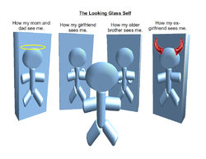

2)

3)

Charles Cooley Looking Glass Theory

“I am not what I think I am. I am not what you think I am. I am what I think you think I am”

Flaws with Theory

Limitation: __________________________________________

This relates to symbolic interactionism because a ____________________________________

________________________________________________________________________________________________
__________. Mead c) Charley Cooley d) A and

