Top 10 Things that Make Humans Special
Humans are unusual animals by any stretch of the imagination, ones that have changed the face of the world around us. What makes us so special when compared to the rest of the animal kingdom? Some things we take completely for granted might surprise you.
10 Speech
The larynx, or voice box, sits lower in the throat in humans than in chimps, one of several features that enable human speech. Human ancestors evolved a descended larynx roughly 350,000 years ago. We also possess a descended hyoid bone — this horseshoe-shaped bone below the tongue, unique in that it is not attached to any other bones in the body, allows us to articulate words when speaking.
9 Upright Posture
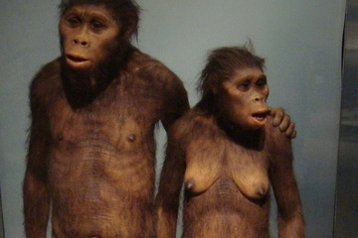
Humans are unique among the primates in how walking fully upright is our chief mode of locomotion. This frees our hands up for using tools. Unfortunately, the changes made in our pelvis for moving on two legs, in combination with babies with large brains, makes human childbirth unusually dangerous compared with the rest of the animal kingdom. A century ago, childbirth was a leading cause of death for women. The lumbar curve in the lower back, which helps us maintain our balance as we stand and walk, also leaves us vulnerable to lower back pain and strain.
8 Nakedness
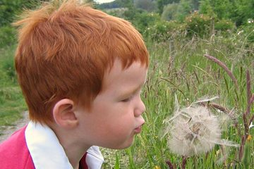
We look naked compared to our hairier ape cousins. Surprisingly, however, a square inch of human skin on average possesses as much hair-producing follicles as other primates, or more — humans often just have thinner, shorter, lighter hairs.

7 Hands
Contrary to popular misconceptions, humans are not the only animals to possess opposable thumbs — most primates do. (Unlike the rest of the great apes, we don't have opposable big toes on our feet.) What makes humans unique is how we can bring our thumbs all the way across the hand to our ring and little fingers. We can also flex the ring and little fingers toward the base of our thumb. This gives humans a powerful grip and exceptional dexterity to hold and manipulate tools with

6 Extraordinary Brains
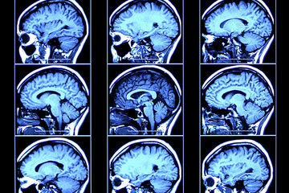
Without a doubt, the human trait that sets us apart the most from the animal kingdom is our extraordinary brain. Humans don't have the largest brains in the world — those belong to sperm whales. We don't even have the largest brains relative to body size — many birds have brains that make up more than 8 percent of their body weight, compared to only 2.5 percent for humans. Yet the human brain, weighing only about 3 pounds when fully grown, give us the ability to reason and think on our feet beyond the capabilities of the rest of the animal kingdom, and provided the works of Mozart, Einstein and many other geniuses.

5 Clothing
Humans may be called "naked apes," but most of us wear clothing, a fact that makes us unique in the animal kingdom, save for the clothing we make for other animals. The development of clothing has even influenced the evolution of other species — the body louse, unlike all other kinds, clings to clothing, not hair.

4 Fire

The human ability to control fire would have brought a semblance of day to night, helping our ancestors to see in an otherwise dark world and keep nocturnal predators at bay. The warmth of the flames also helped people stay warm in cold weather, enabling us to live in cooler areas. And of course it gave us cooking, which some researchers suggest influenced human evolution — cooked foods are easier to chew and digest, perhaps contributing to human reductions in tooth and gut size.
3 Blushing
Humans are the only species known to blush, a behavior Darwin called "the most peculiar and the most human of all expressions." It remains uncertain why people blush, involuntarily revealing our innermost emotions. The most common idea is that blushing helps keep people honest, benefiting the group as a whole.

2 Long Childhoods

Humans must remain in the care of their parents for much longer than other living primates. The question then becomes why, when it might make more evolutionary sense to grow as fast as possible to have more offspring. The explanation may be our large brains, which presumably require a long time to grow and learn.

1 Life after Children
Most animals reproduce until they die, but in humans, females can survive long after ceasing reproduction. This might be due to the social bonds seen in humans — in extended families, grandparents can help ensure the success of their families long after they themselves can have children.

