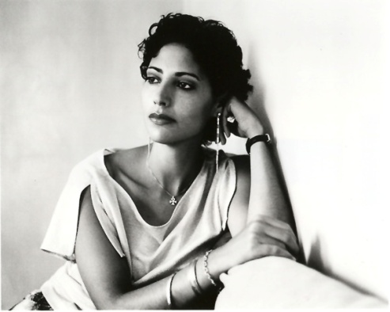
Suheir Hammad- Spoken Word Poet
Brief Bio: Suheir Hammad, born in Jordan and raised in New York ("Suheir Hammad Biography" par. 1), is the eldest of five children. While growing up in New York, she was heavily influenced by her cultural, religious, and social surroundings (Khan). Hip hop culture also had an effect on her writing and her performance (Palcast). The Quran was also a huge part of Hammad's parents and grandparents life; she was taught that the Quran is poetry, and it is the holiest scripture in the Muslim religion (Rodriguez).
Hammad’s poems often focus on political topics. One of the main reasons she writes poetry is because it allows her to make a connection between her individuality and her culture. Unlike other Palestinian poets Hammad doesn't feel restrained to stand up in her poetry (Brown). She has also traveled the world with her poetry and has read it in different events (Famous Poems and Poets). Her poems are full of passion and rhythm ("Born Palestinian, Born Black") https://sites.google.com/site/gallagheronpoetry/suheir-hammad

"Exotic" - Suheir Hammad
Don't wanna be your exotic
Like some delicate fragile colorful
bird imprisoned caged in a
land foreign to the stretch of her wings
Don't wanna be your exotic
women everywhere look just
like me some taller darker
nicer than me but like me
Just the same women everywhere
carry my nose on their faces
my name on their spirits
Don't seduce yourself with my
otherness
the beat of my lashes
against each other ain't some
dark desert beat it's just
a blink get over it
Don't build around me
your fetish fantasy your
lustful profanity to
cage me in clip my wings
Don't wanna be your exotic
your loving of my beauty ain't
more than funky fornication
plain pink perversion in
fact nasty necrophilia
because my beauty is dead
to you
I am dead to you
Not your harem girl
geisha doll banana picker
pom pom girl poom poom short
coffee maker town whore
belly dancer private dancer
la malinche venus hottentot
laundry girl your immaculate
vessel emasculating princess
don't wanna be
not your erotic not your exotic

