Sociologists Summoned!
Below are some of the most influential sociologists, past and present. However, you should always remember that (as with any social science) theories are continually modified as new information surfaces, and more often than not, an individual’s findings are reviewed, critiqued, and compared by colleagues (or discovered as part of a team). In other words, sociology is rarely an isolated, individual activity.

Auguste Comte | 1798 - 1857 | 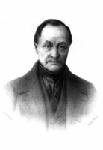  Auguste Comte | Inventor of the term sociology, functionalist Comte argued that societies changed over time, sometimes finding equilibrium and other times not. Comte also introduced positivism into sociology, which added authority and legitimacy to the social sciences.
Emile Durkheim | 1858 - 1917 | 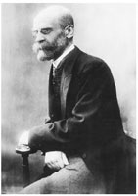  Emile Durkheim | Durkheim also believed in using the scientific method in order to discover a better society. He focused on prisoners and suicide as means for identifying and resolving societal problems. Though a functionalist, Durkheim wanted to help both individuals, and through that, society as a whole.
Karl Marx | 1818 - 1883 | 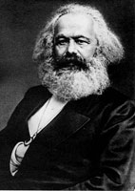  Karl Marx | Famous for his Communist Manifesto, Marx believed that history could illustrate why societies face problems. Social inequity based on materialism and wealth distribution needed to be rectified (through conflict) to the masses (proletariat) in order to allow for a better society.
Max Weber | 1864 - 1920 | 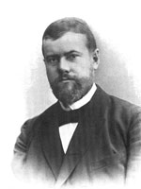  Max Weber | Another Conflict sociologist, Weber expanded Marx’s focus to education, politics, religion, and families. He did agree that conflict existed, but argued it could be more structured and thus could be regulated through the formation of government bureaucracies.
Talcott Parsons | 1902 - 1979 | 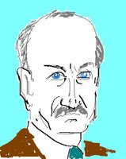  Talcott Parsons | Creator of the structural functionalism theory, Parsons believed that society was the sum of its parts. Diversity exists and so societies utilize symbolic forms to permit people to interact, but also adapt, identify, and incorporate. As opposed to Conflict sociologists, Parsons was optimistic that functional society would benefit the masses.
George H. Mead | 1863 - 1931 | 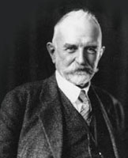  George H. Mead | A symbolic interactionalist, Mead believed that society was more than the sum of its parts, and that we, as individuals, play an important role. However, our actions are not always taken at face value, and so meaning is layered on by other people, which in turn affects their decisions, interactions, and actions.
Noam Chomsky | 1928 - Present | 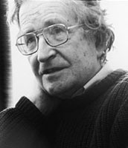  Noam Chomsky | A world famous intellectual, Chomsky has been labelled an anarchist for his critique of modern day societies. However, his focus is that the individual needs to take responsibility for their societal inclusion, through questioning and thinking for themselves.

