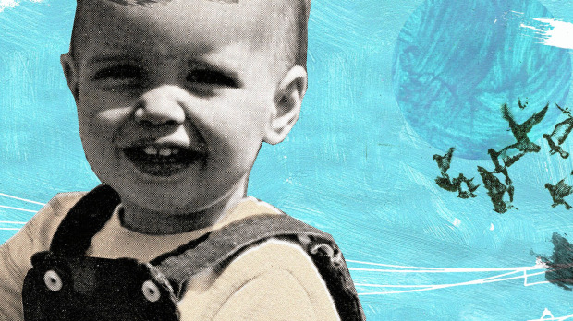

Tara Hardy/The Globe and Mail

As a stay-at-home dad, I understand Betty Draper

paco francoli

Last updated Tuesday, Mar. 27, 2012 7:35PM EDT
I finally get Mad Men. Before, I sort of got it. I sort of got how the sexism of the 1960s, a main storyline of the popular TV show, made the lives of most women pretty tough, if not unbearable.
But, now, boy do I get it.
Why now? Why this sudden revelation?
I just spent the past six months at home on paternity leave with my son Xavi – my wonderful, amazing little boy who just turned 1.
I love Xavi to bits. There is nothing better in the world than seeing his gummy, smiling face. But if I have to spend another day keeping him fed, clothed and entertained, while juggling basic household chores, so help me God.
Most days, when my wife comes home from work, my mind is a blank and my body is drained. I greet her with a vacant expression that often stops her in her tracks.
“What’s wrong? What happened?” she asks.
“Nothing. We had a great day,” I reply.
Which is true most days, days that can include any or all of the following: waking up far too early to the sound of screaming; obsessing over naps; talking nonsense; rolling around on the floor with plastic toys; and walking aimlessly around the neighbourhood.
It’s not very glamorous. And the routine is doing my head in.
The other day, Xavi managed to blurt out, “Bababuah,” which wasn’t bad considering all the sounds he strung together. But this was how he responded after I asked him if he had a good nap. He then scrunched up his face, grunted and pooed in his Mickey Mouse diaper.
If only I could reason with Xavi, have a conversation, explain to him why it’s a problem when he wakes up 20 minutes into his first nap. “Don’t you understand?” I plead with real panic in my voice. “Our day now sits on a precipice. Who knows where it’ll go from here?”
And he won’t sit still. Ever. Try going to a coffee shop to relax, even for five minutes. I bring an arsenal of toys and treats to keep him busy. But it’s no use. Nine times out of 10, I end up chugging my coffee and fleeing the scene.
How I long for those easy, halcyon days at the office, days that can include any or all of the following: working quietly on something by myself; having a coffee break by myself; chit-chatting with people my own age; and earning plaudits for work well done (at least some of the time).
I frankly don’t understand how my mother – a stay-at-home mom until my sister and I were well into primary school – put up with the routine all those years before going back to school in her late 30s and eventually enjoying a successful academic career that continues to this day.
In fact, she often looks back wistfully on those years at home and invariably says, “If only I had been more patient.”
But it’s hard to be patient when you’re dealing with a creature.
It was during the Enlightenment that we started thinking of children as innocent creatures of nature. It was to bring home the point that kids are mostly helpless and require selfless caring, guidance and nurturing.
It’s an apt description. I could testify to it for hours.
So could Betty Draper, the unhappy housewife in Mad Men. In one episode, we find her shooting at the neighbour’s pet pigeons with a BB gun, a cigarette dangling from her lips. What drove her to this? She tried and failed to get a job as a model and, in the process, escape her stay-at-home life.
Now Betty Draper would never win the parent-of-the-year award. Most days, she’s a cold fish toward her kids and is happy to leave child-rearing duties to the nanny. But it’s easy to sympathize with her situation, especially when taking into account her philandering, career-obsessed husband Don Draper.
The kicker is that this is my second tour of duty. Xavi has a big sister, Sofia. I spent five months on leave with her. And I suppose that, if we have another little bundle of joy, I’d do it all over again. I’d do it in a heartbeat. I wouldn’t want to miss out on such an opportunity to bond with my child during those amazing months when they learn so many things for the first time – everything from sitting to walking, smiling to laughing, babbling to uttering their first words.
But I’d make the decision knowing full well that the situation would be temporary. I’d eventually be able to go back to work. My life wouldn’t be on hold indefinitely.
Still, we live in uncertain times. The economy remains sluggish and it’s possible there wouldn’t be a job for me to return to. And if that were to happen, well, I suppose the neighbourhood wildlife better watch out.
Paco Francoli lives in Ottawa.

