Psychologists Present!
Below are some of the most influential psychologists, past and present. However, you should always remember that (as with any social science) theories are continually modified as new information surfaces, and more often than not, an individual’s findings are reviewed, critiqued, and compared by colleagues (or discovered as part of a team). In other words, psychology is rarely an isolated, individual activity.
William James | 1842 - 1910 | 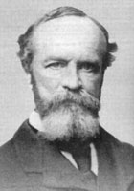  William James | Considered the father of psychology, in 1890 William James wrote a 1200 paged text entitled the Principles of Psychology. He focussed on emotional psychology, and is famous for his Bear analogy.
Sigmund Freud | 1856 - 1939 | 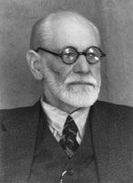  Sigmund Freud | Freud revolutionized psychology  and left us with a large legacy including, psychotherapy. Freud based his theories on his patients, most of whom had various degrees of mental illnesses, and emphasized the importance of sexual development.
Erik Erikson | 1902 - 1994 | 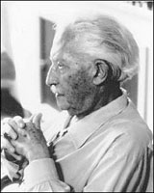  Erik Erikson | A follower of Freud, this neo-Freudian wrote about his theory of psychosocial development, which plotted out the healthy stages a human should pass through from birth to late adulthood. He also described where and when people gained various virtues (hope, love, wisdom).
Carl Jung | 1875 - 1961 | 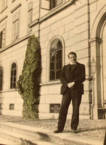  Carl Jung | Another neo-Freudian, Jung expanded Freud’s theories beyond the sexual realm and introduced analytical psychology, whereby the individual’s inner thoughts were connected to the larger, collective society. If you want to see Jung’s theory on the big screen, look no further than Star Wars!
B.F. Skinner | 1904 – 1990 | 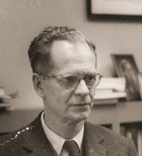  B.F. Skinner | As a radical behaviourist, Skinner denied Freud’s findings and argued instead that humans react to stimuli through responses. His theories were data focussed and denied the existence of free will. This is ironic since Skinner was also a strong social reform advocate!
John B. Watson | 1878 - 1958 | 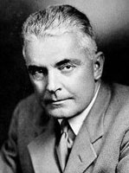  John B. Watson | A traditional behaviourist, Watson argued that external conditioning could shape personality completely. Watson believed accuracy and consensus in data collection was essential to ensure a theory had validity.
Jean Piaget | 1896 - 1980 | 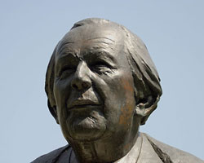  Jean Piaget | A cognitive psychologist, Piaget is most famous for his “stages of cognitive development”, a theory developed through his long term studies of children.

