Label the Parts of the Brain as we go through the PowerPoint:
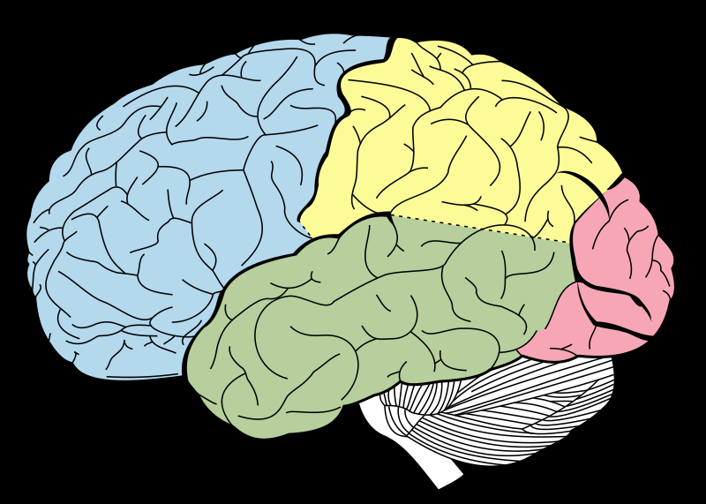

Describe the Function Each Part:
Frontal Lobe: ____________________________________________________________________________________________________________________________________________________________________________________________________________________________________
Parietal Lobe: ____________________________________________________________________________________________________________________________________________________________________________________________________________________________________
Occipital Lobe: ____________________________________________________________________________________________________________________________________________________________________________________________________________________________________
Temporal Lobe: ____________________________________________________________________________________________________________________________________________________________________________________________________________________________________
Cerebellum: ____________________________________________________________________________________________________________________________________________________________________________________________________________________________________
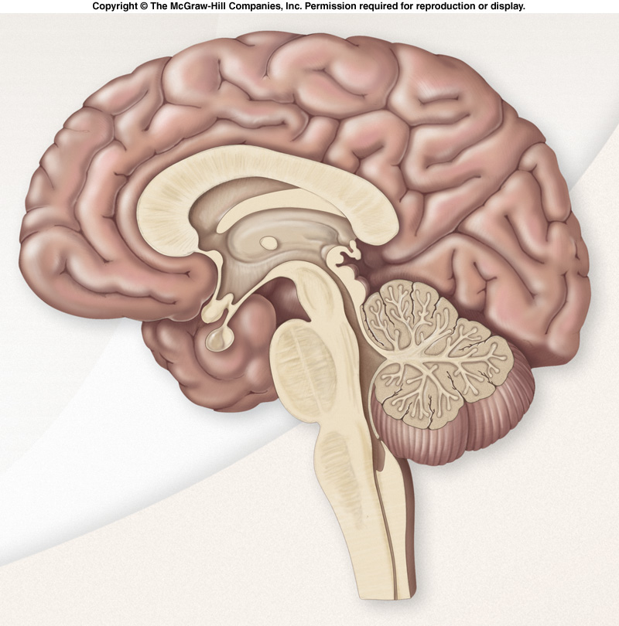

Label the following part of the brain and describe their functions below:
Thalamus: ____________________________________________________________________________________________________________________________________________________________________________________________________________________________________
Hypothalamus: ____________________________________________________________________________________________________________________________________________________________________________________________________________________________________
Amygdala: ____________________________________________________________________________________________________________________________________________________________________________________________________________________________________
Hippocampus: ____________________________________________________________________________________________________________________________________________________________________________________________________________________________________
Pons: ____________________________________________________________________________________________________________________________________________________________________________________________________________________________________
Medulla: ____________________________________________________________________________________________________________________________________________________________________________________________________________________________________

