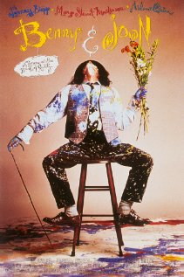
Benny and Joon (1993)

- What is hanging from the ceiling in Joon’s art room?

- What book is Johnny Depps’s character reading on the train?

- What does Miss Smail say about Joon’s behaviour?

- What does Benny say Joon does when she is on her own?

- What does Joon’s therapist say about Joon’s living situation?

- What is Benny and Joon’s relationship? How long have they been on their own?

- What does Joon’s Medical Alert card say under the section “Special Illness”?

- What dilemma is Benny facing when it comes to Joon’s well-being

- How does Sam come to live with Benny and Joon?

- Who is Sam?

- What are some “symptoms” of Joon’s mental illness?

- What happened to Benny and Joon’s parents?

- What type of relationship to Sam and Joon develop?

- What does Benny come to realize about Joon and her mental illness?

Journal Activity:
Now that you have finished watching Benny & Joon, and read the article “Mental Illness Portrayed in Benny & Joon”, take a few moments to write about the overall message of the film. What are some of the stigmas people with mental health problems face? How do we as a society perpetuate these stigmas? What are some ways we can stop them?
____________________________________________________________________________________________________________________________________________________________________________________________________________________________________________________________________________________________________________________________________________________________________________________________________________________________________________________________________________________________________________________________________________________________________________________________________________________________________________________________________________________________________________________________________________________________________________________________________________________________________________________________________________________________________________________________________________________________________________________________________________________________________________________________________________________________________________________________________________________________________________________________________________________________________________________________________________________________________________________________________________________________________________________________________________________________________________________________________________________________________________________________________________________________________________________________________________________________________________________________________________________________________________________________________________________________________________________________________________________________________________________________________________________________________________________________________________________________________________________________________________________________________________________________________________________________________________

