Some Specific Forms of Government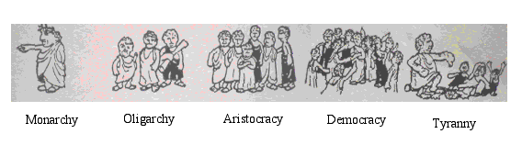
Governments around the world
- There are over 200 countries in the world - each with their own forms of government that have evolved along very different paths. Listed below are some of the different forms of government, including countries that have adopted their styles of rule. Remember, different combinations of government can exist (i.e. a dictatorship that is also a monarchy).
_______________________________________________:
Historically, one-person governments were far more common than democracies. Over time, one-person dictatorships have diminished in number.
In such a system, a single individual holds all the power in the state. There is nothing that restricts his power. There is no constitution, opposition parties, independent labour unions, or free press to challenge his authority.
Hitler's Germany, Mussolini's Italy, Pol Pot's Cambodia are examples from the past. Kim Jung Un is a present example.
________________________________________________:
A monarchial system of government is one in which power is passed on through a hereditary head of state.
Power in such a system may rest in a single individual's hands, such as Japan's Hirohito prior to World War Two. Or it may be a constitutional monarchy, such as that of Canada today, in which the monarch has only a ceremonial function and no real power.
_________________________________________________:
In oligarchic governments, power rests in the hands of a few. Usually, they are small elite who makes decisions on behalf of society.
In Canadian history, the Family Compact in Upper Canada and the Chateau Clique in Lower Canada in the days prior to the Rebellions of 1837, are examples of such a system.
Military juntas, in Central and South America, are more recent examples. This system can take on several different forms such as:

___________________________________________________:
A government ruled by or subject to religious authority. The highest religious or spiritual leaders hold power. For example - Iran and Vatican City.
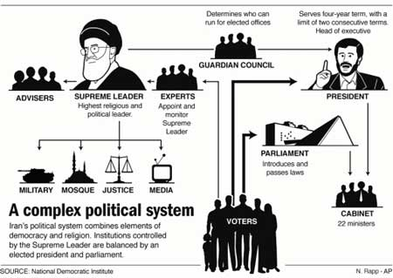
___________________________________________: a government state in which a few wealthiest individuals wield power. I.e. Ancient Greece.
Prior to the early 20th century, many countries used a system where rich persons had more votes than poor. A factory owner may for instance have had 2000 votes while a worker had one or if they were very poor no right to vote at all. In the US, it would take until 1945 before persons living on welfare would get voting right.
______________________________________________:
An aristocratic government is one in which the 'highest' citizens have power. The privileged class, usually a combination of birth and wealth, make most of the important decisions. Such individuals are thought to be superior because of their birth or wealth, and therefore are given power
________________________________________________:
A democratic system allows the greatest number of people access to power. The people in fact are the government. Decisions are usually made by majority vote. A democracy may take on either of two forms - direct and indirect.
In a direct democracy, the people themselves directly decide. This was the case in Ancient Athens when it was small enough that such a system worked.
In an indirect democracy, the people elect representatives who make decisions on their behalf.

