Anthropologists Assemble!
Below are some of the most influential anthropologists, past and present. However, you should always remember that (as with any social science) theories are continually modified as new information surfaces, and more often than not, an individual’s findings are reviewed, critiqued and compared by colleagues (or discovered as part of a team). In other words, anthropology is rarely an isolated, individual activity.
Margaret Mead | 1901 – 1978 | 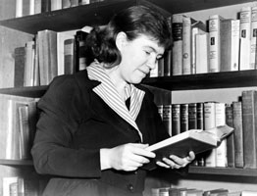  Margaret Mead | Mead studied the Pacific islands cultures, most famously Samoan. She frankly compared and contrasted each cultures’ adolescent experiences, and concluded that cultural forces often determined an individual’s development. She also examined gender roles.
Ruth Benedict | 1887 – 1948 | 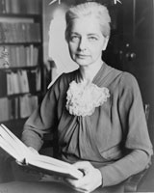  Ruth Benedict | In her most famous work, Patterns of Culture, Benedict argued that cultures ‘pick’ personality traits to emphasize, at the expense of others. For example, competition in North America is highly valued.
Radcliffe Brown | 1881 – 1955 | 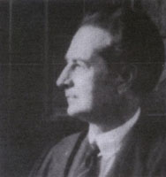  Radcliffe Brown | Considered one of the founding fathers of social anthropology, Radcliffee Brown helped develop the theory of Structural Functionalism, a theory that describes how the social structure in primitive civilizations existed and persisted.
Leakey Family | 1903 – | 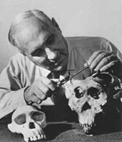  Leakey Family | A Kenyan born anthropologist, Louis Leakey and his family were key figures in establishing the “Out of Africa” theory of evolution. He and his family primarily studied biological anthropology, largely focusing on fossil records and found tools.
Jane Goodall | 1934 – | 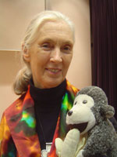  Jane Goodall | World renown for her work observing chimpanzees, Jane Goodall lived amongst the chimpanzees for 20 years! During this time she discovered and recorded a detailed social structure, including a complex hierarchy, use of tools and even cannibalism.
Franz Boas | 1858 - 1942 | 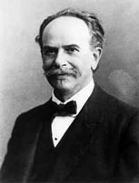  Franz Boasl | Dubbed the “Father of American Anthropology”, Boas is famous for incorporating the scientific method into anthropology, thereby adding scientific legitimacy to future theories and research. He worked in all four of anthropology’s fields.
Marius Barbeau | 1883 – 1969 | 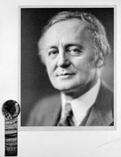  Marius Barbeau | Heralded as the “Founder of Canadian Anthropology”, Barbeau studied early Quebecois culture, as well as Tsimshianic people’s culture. His exhaustive work, and interactions with other famous anthropologists, helped establish the discipline here in Canada.

