Spousal Violence
What is Spousal Abuse?
Family violence consists of violence, abuse, and neglect between and among family members. Relationship violence, spousal abuse, child abuse, and elder abuse are all forms of family violence.
Family violence and spousal abuse have only recently been subjected to academic research. Prior to 1930, the term “family violence” was not used by social scientists. The pathology was not recognized until 1946, when a case study examined an unexplained childhood injury, and a 1962 hospital study identified several incidents of child abuse.

Spousal abuse may be characterized as interpersonal abuse, systemic abuse, or non-systemic abuse.
What are the Causes of Spousal Abuse?
Feminist sociologists believe that patriarchal social systems validate male dominance. Attitudes of appropriate masculinity begin in childhood, and include characteristics of strength, power, control, and aggression. These descriptors are magnified in the attitudes of male abusers. Conflict theorists explain spousal abuse as the result of an imbalance of power between the spouses. When dominance is threatened, abuse is used as a method to regain power. Spousal abuse is more common when the husband is unemployed but the wife has a job than in the reverse situation, or when both spouses are unemployed. Egalitarian relationships have lower incidents of abuse, as power is shared between the spouses.
What are the Characteristics of Spousal Abuse?
The extensiveness of family violence is difficult to accurately determine, as it tends to be underreported and understudied. Access to data, such as hospital records, tends to be restricted. The best predictors of spousal violence are work-related stress and marital conflict. Psychological characteristics of abusers include jealousy, insecurity, and immaturity.
The majority of spousal abuse is against women. Less frequently, spousal abuse occurs against men, and against partners in same-sex relationships. Relationship violence occurs more frequently within common-law relationships than marriages. Numerous types of spousal abuse are underreported due to the victim’s shame and the associated social stigma.
Spousal abuse occurs in every socioeconomic group. Perpetrators are commonly men with violent family histories. These partners tend to believe that they are entitled to control their spouses, consider them sexual and emotional property, and establish their power through abusive behaviours. Substance abuse, low education, and frequent spousal conflict are typical characteristics of abusive husbands. Some social science researches attribute family violence to environmental characteristics, such as poverty, the glorification of violence, poor housing, and unemployment.
Victims often misunderstand abuse for a “normal” expression of love and anger. Abuse may be tolerated in exchange for the perpetrator’s positive attributes, such as income or social status. Victims may be blamed for instigating the abuse, or blame themselves. Victims may be persuaded to stay in an abusive relationship by their spouse’s seemingly sincere expressions of grief and promises to change. Abusive incidences are rarely isolated, nor do they end spontaneously and without intervention.
Psychologists explain that abused victims are unable to leave the abusive relationship because they have developed battered woman syndrome and are unable to perceive any other alternatives. Dependent children complicate the options. Some possibilities, such as moving out, are not viable options to women who cannot afford them, who have no safe place to go, or who fear their spouse’s reactions. After living in situations marked by oppression, isolation, and financial dependency, many battered women have lost the ability to make decisions for themselves.
Date rape and abuse occur approximately as often as spousal abuse. Violent relationships tend to originate well before adulthood. Children who experience or cause violence are likely to continue the pattern, and can cause or be the victim of violence in dating and marital relationships.
The Strauss Conflict Tactics Scale, first designed in 1979, is used for measuring the extent of family violence. This tool assesses physical violence and verbal aggression, and identifies high-risk situations based on the frequency and severity of the incidents.

Did You Know?
- 8% of Canadian women and 7% of Canadian men reported at least one violent incident between 1994 and 1999.
- Between 1994 and 1999, 20% of Aboriginal partners experience spousal abuse, compared to 7% of non-Aboriginal men and women.
Health Canada: The Family Violence Initiative Year Five Report
What are the Consequences of Spousal Abuse?
Marital violence perpetuates the cycle of abuse; abusive husbands are often abusive fathers; abused kids tend to grow up and become abusive or abused spouses. Spousal abuse is a major factor in marital dysfunction and breakdown. Abused spouses suffer physical, psychological, mental, emotional, and financial effects. Extreme abuse has led to victims’ deaths.
What are some Prevention and Remediation Strategies?
Domestic violence has largely been perceived as a private family problem. However, social attitudes are changing, and spousal abuse is being taken more seriously by social systems such as the legal system. Still, social service supports are insufficient to meet the demand. Legal protocols need to be more stringent and more consistently applied to perpetrators. Specific relationship abuse programs and protocols, such as restraining orders, treatment programs, and mandatory arrests are less effective in reducing violence than programs designed to address underlying causes of abuse, such as substance issues.
Educational initiatives are important strategies for avoiding violent relationships. Young people need to be educated about what abuse consists of, how it begins, and the likely outcomes of abuse. The Statistics Canada series, Family Violence in Canada: A Statistical Profile, is a federal public education resource that has received widespread media coverage. Community workshops, resource development, culturally specific media programs delivered in the community’s first language by local individuals, and pilot projects have raised public awareness of family violence.
Reducing family stress levels would also influence family violence rates. Increased social support for families with small children, professionals who are equipped to deal with a diverse range of individuals stressed by a variety of problems, and increasing open communication about family violence are all proactive solutions that would reduce family violence.
A concern for family abuse responses in Canada’s diverse society is to develop effective programs and treatments that are culturally appropriate and address the wide range of circumstances in various communities. Multifaceted initiatives involve the criminal justice, social, housing, and health services to respond to the many needs of family violence victims. Effective programs tend to be ones that the community has ownership in and control over, especially for encouraging Aboriginal, rural, and specific cultural communities.
Health Canada works with federal and provincial government agencies, as well as NGOs to deliver the Family Violence Initiative. The mandate of the Family Violence Initiative aims to increase public awareness of family violence risk factors, increase public response to family violence, empower social and legal systems to respond effectively, and promote research initiatives to identify effective intervention strategies.
Did You Know?
Key Dates in Canada
1965 Ontario is the first province to legislate reporting of child abuse.
1972 Canada’s first shelter for abused women opened in Vancouver.
1989 Major Canadian survey completed on elder abuse.
1993 Statistics Canada conducts Violence Against Women Survey.
Vanier Institute of the Family
Violence in relationships occurs more frequently than one believes. According to Statistics Canada, in 1999, 12% of women and 7% of men reported that they have been the victim of violence or have been mistreated for the past five years in their marriage or common law relationship (Statistics Canada, 2006).
Spousal violence is not a new phenomenon as it has been in existence for centuries, however the term “violence” was not defined as it is today. In the 19th century the “rule of thumb” was an expression used that allowed a man the right to use a stick no thicker than his thumb to beat his “chattels”: wife, children, and servants. In the 20th century, domestic violence was considered a private matter and police could only lay charges if they witnessed the assault and/or violence. Women would go see pastors or clergy for advice about the violence within their home, however, they were often advised to return home and work out the conflict with their spouse.
Women were not encouraged to leave their spouse or the marriage and women who chose to leave were guilty of desertion, and would be penalized by losing custody of their children and receiving no financial support. By the 1970s the women's movement became involved in the issue of violence against women, and this led to a change in public opinion about violence within intimate and domestic relationships. With this change in attitude towards violence against women, police have now become more involved in domestic violence and are now required, by law, to respond to all domestic violence calls and lay charges should any form of evidence be visible.
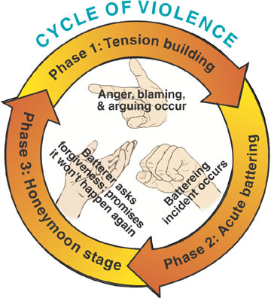
Violence in relationships can occur for a number of reasons. People who have been violated or exposed to violence or abuse as a child are at risk of becoming either victims or perpetrators of violence in intimate relationships as adults. This is known as the intergenerational cycle of violence. The cycle of violence has three phases:

1. Tension-Building Phase (walking on eggshells) | The victim works to make the abuser happy. The victim works diligently to appease the abuser as s/he views the abuser's tension beginning to build. Once an outburst occurs the victim rationalizes the outburst and often accepts responsibility for what has just occurred.
2. Abusive Incident Phase (explosion) | An unpredictable event may have set off the abuser thus creating a violent attack on the victim. The unpredictable event can include anything from a bad day at work, not enjoying the meal at dinner, or even losing a sporting match on television. The level of abuse is relevant to the event and its affect on the abuser.
3. Calm and Penance Phase (honeymoon) | The abuser becomes remorseful for the abuse and pledges forgiveness and promises never to abuse again. This is also known as the “honeymoon” phase where everything is great until tension begins to build again, therefore setting the stage for the cycle to begin at the tension-building phase.

The systems theory explores why women tend to stay in abusive relationships. According to the systems theory, a couple has set a relationship routine that is “normal” for them and in any instance that routine is difficult to break.
The social exchange theory states that in the case of violence where a woman leaves the relationship, she would often fear for her life and believe that it will be worse should she return to him or if he find her.
The feminist theory suggests that as men lose power within their social environment, particularly their careers/jobs, they try to regain that power by exerting control in the family. Men acquire power by gender, age, size, and strength and therefore are able to “control” the environment within the home, whereas in the public field they are unable to “control” their environment. When a woman threatens to leave or even do something about a relationship, the man believes that he is losing “control” of his private life; therefore the level of abuse escalates.
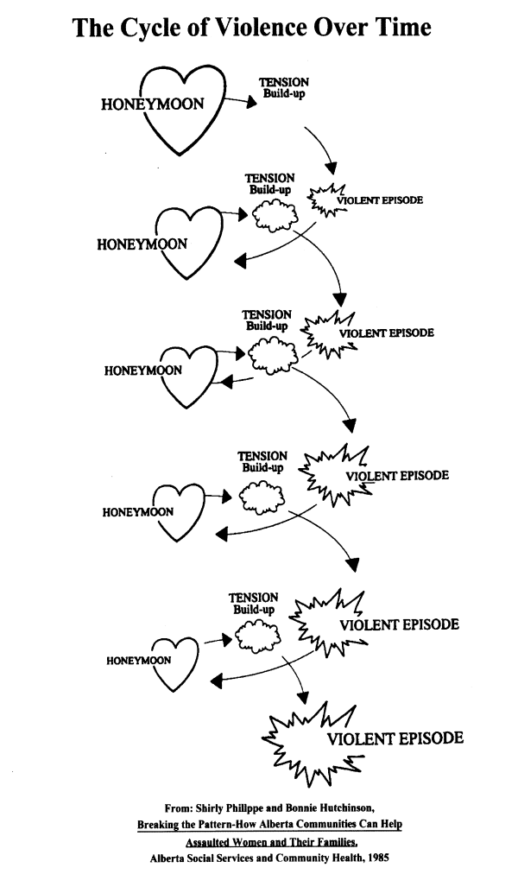
Many women may stay in an abusive relationship for the safety of their children. As long as they're the one being abused, perhaps the children will be safe, but if they leave the relationship then fear for their children becomes a factor.
There are social support networks available to women and children in violent relationships. Domestic laws today allow the police to become more readily involved; shelters, counselling services, and restraining orders are all viable options available to help in “escaping” and reducing the violence within relationships.

