Communism and Fascism
These two totalitarian ideologies were significant during the 20th century. The communist Soviet Union and the fascist states of Europe were at the heart of the Second World War and Cold War. While less significant today, they remain models of applied utopianism.
- Marxism
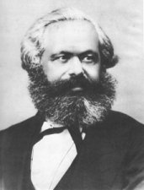
Karl Marx (1818-1883), a German philosopher who spent most of his life in France and England, was by far the most influential of socialist thinkers. Marx had an interesting and tragic personal life, spending most of it on the run, and in exile-he was buried in London. As a result of the great poverty in which he and his family lived, several of his children died while he wrote his most famous works.
While borrowing from the ideas of other socialists, he demonstrated how the theory was not as bankrupt as the many failed utopian experiments would seem to demonstrate. Marx was not a utopian; he saw himself more as a historical theorist, who examined patterns in history, and in particular economic history, to predict what the future would hold. By creating scientific socialism, he rescued from oblivion the idea of re-distribution of wealth for the benefit of all.
Marx's studies showed him that capitalism was doomed. In Das Kapital, Marx argued that the natural greediness of the capitalist ruling class would lead them to oppress the working class more and more, until the working class would rise up and overthrow them. What would replace the capitalist order would be a communistic society, in which wealth and labour would be distributed equally according to the maxim, "From each according to his ability, to each according to his need". Eventually, even this form of organization would wither away and everyone would live in equal, happy, anarchy.
While Marx saw this process as a historical inevitability that required no help, others saw an opportunity to speed things up. Revolutionary Marxism was, in fact, contrary to Marx's view that the process was inevitable. Eventually, these Marxists so dominated the socialist movement that Marx declared that he was not a Marxist. Many were inspired by his ideas, often in ways of which he would likely have disapproved.
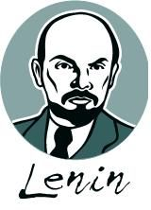 | The most notable of the Marxists was the leader of the Russian Revolution, Vladimir Lenin (1870-1924). A hard-core, professional revolutionary, he created the ideology of revolutionary Marxist-Leninism, a hybrid of Marx's theory of historical inevitability and his own tactics to help speed about the communist utopia. This plan in action resulted in the creation of the Soviet Union (1917-1991), which transformed the Russian Empire into a socialist state based on equality of ownership. However, the process was not a kind one, and Lenin was completely ruthless, advocating and carrying out mass murders, genocide, and war to accomplish his goals.
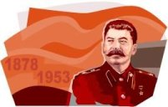 |  | Josef Stalin (1878-1953), who took over the Soviet Union after Lenin's death, went much, much further, with his ruthless attempt to implement socialism. He created a terror-state, responsible for tens of millions of deaths, in which no one was safe and the individual was considered completely insignificant compared to the great project of socialism. The form of totalitarian government endorsed by Stalin, with its repression of individual liberties, was denounced later by new Soviet leaders.
However, the Soviet Union was never able to create any sort of socialist utopia. The socialist experiment did succeed in modernizing a backward country and brought some benefits, such as greater literacy and improved health care, but at a high cost. For most of its time, most of its people lived unhappy, impoverished lives, poor both materially and spiritually. Many suffered greatly. The collapse of the Soviet Union in 1991 has greatly discredited the idea of creating a socialist state in a large powerful country. A few communist societies continue today, Cuba and China being the most successful.
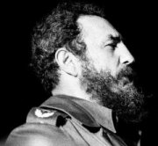  Portrait of Fidel Castro.  Public domain image |  | The Cuban Revolution, led by Fidel Castro (born 1926), succeeded in 1959. Cuban socialism was popular because of Castro's strong personal leadership and a populace that would not support the corrupt, American-capitalist supported regimes that preceded it. It remains so today, except amongst the Cuban expatriates who fled the island after Castro triumphed. Castro has achieved a near 100% rate of literacy (from less than 50% prior to 1959) and provided high-quality health care for all. However, Cubans don't have access to the latest consumer products and have suffered economically after losing the heavy subsidies that the Soviet Union provided them for exports such as sugar. Castro's Cuba probably most closely approaches the type of socialist utopia for which many communist thinkers wished.
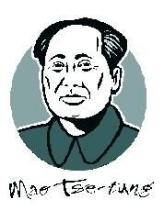 | In China, Mao Zedong (1893-1976), often translated into English as Mao Tse-Tung, also used the ideas of Marxist-Leninism and created another brand of communist revolutionary movement, establishing the People's Republic of China in 1949. Another socialist utopia, this one too had problems with human rights abuses. Mao's grand experiments like the Great Leap Forward and the Cultural Revolution left millions of corpses and brought no discernible benefit.
After Mao's death, the Communist Party of China began a program of modernization that took it quite a distance from Mao's original vision. While still technically a socialist state, China now allows private ownership of property and entrepreneurial capitalism. In fact, most of the millionaires in China are members of the Communist Party. China is now experiencing the sort of widening disparity between rich and poor that Marx characterized as capitalism on its way to oblivion.
Fascist Utopias
Fascism is a political ideology invented by Benito Mussolini (1883-1945), Italian Prime Minister from 1922-1943. He borrowed the term "fasces" from the Roman symbol of the authority of the magistrates, a bundle of rods with an axe. Mussolini's version of utopian society is drawn from a wide range of others, put together to suit his purpose.
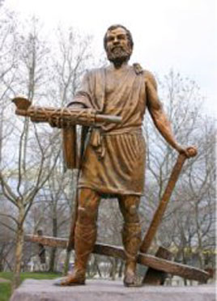 | The photograph to the left is the Statue of Cincinnatus, Cincinnati, OH, 2004, by Rick Dikeman. The subject of this sculpture holds the fasces lictoriae in his right hand, a bundle of rods that were bound together, symbolizing power and authority in ancient Rome. The term fascist comes from a Roman word, fasces. "With one hand he returns the fasces, symbol of power as appointed dictator of Rome. His other hand holds a plow, as he resumes the life of a citizen and farmer."
Fascism is remarkably simple and can be summed up in Mussolini's dictum "Believe! Obey! Fight!" It is not an ideology for thinkers, but for doers. "Irrationalism" is a central concept of fascism-feel the truth, don't think too hard. Do as you're told and don't ask questions. Mussolini was known as "Il Duce", the leader. His word was, in theory, absolute. In practice, Mussolini had to engage in clever political manoeuvring to keep in control of the movement he created.
The most important element of fascism is statism. The state is seen as organic, that is, alive, with the need to be. Personal happiness is unimportant, what counts is the state. When the state is working harmoniously, when all members of the state work to benefit it, there is a sort of synergy, and the sum of the whole society will be greater than its parts. In short, if everyone dedicates themselves wholly to the state, putting aside their own happiness and needs, they will be much happier in the long run. The higher life they will achieve would be much greater than their individual, self-centered life. This theory is often compared to that of bees in a hive. By subjugating themselves to the hive, the worker bees reap the benefits of participating in its great enterprise.
This need to promote the higher life of the state requires that the state intervene in every aspect of your life. This is not the sort of totalitarianism that Plato is accused of; in fact, Mussolini coined and defined the term. A fascist state is the total of your life, it takes control of it--as Mussolini stated, "Everything for the state; nothing against the state; nothing outside the state". Personal liberty and rights are alien to this notion of statism.
Mussolini was brutal with opponents. However, he brought stability to the chaos that characterized Italy in the 1920's. Mussolini remained quite popular until the Second World War, in which he was overthrown and Italy was thereby able to switch from the Axis to the Allied side. Even today he enjoys considerable popularity, and fascism is a viable political movement in Italy today. He is often praised as an example of the stern measures sometimes needed for society to succeed. Mussolini "made the trains run on time", and while this is generally a good thing, in this case it required rather harsh measures to make it happen.
The problem with fascism is that humans are not bees. The theory leads to oppressive totalitarian regimes that oppress segments of their citizenry. While many may appreciate the "strongman" in a crisis, such as plagued Italy in the 1920's, once stability is restored they often resent their lack of civil and personal liberties. While the simplicity of the fascist message was very attractive, the movement was short lived. Many European countries had fascist governments during the 1930s, such as Italy, Germany, Spain, and Hungary, with fascist parties existing in most of the western democracies. In the post-War period, fascism survived in Spain and Portugal until the 1970s, and it was popular in many South American countries from the 1940s to 1990s

