Read the article Violence Against Women: Statistical Trends. Complete the following questions after you have read the article.
- Describe the graph on spousal homicide rates in the territories by age group and sex of victim, 1975 to 2004. In your opinion why do you think the numbers for victims in the ages of 15-24 are far greater than any other age bracket?
______________________________________________________________________________________________________________________________________________________________________________________________________________________________________________________________________________________________________________________________
- Do the percentages of male victims surprise you? Why or why not? Explain.
______________________________________________________________________________________________________________________________________________________________________________________________________________________________________________________________________________________________________________________________
- The study in the article reflects the three territories in Canada. How do you think the numbers in Ontario would compare? Explain.
______________________________________________________________________________________________________________________________________________________________________________________________________________________________________________________________________________________________________________________________

- Spousal homicide and assaults against women have declined according to the article. Are you surprised with this finding? Explain.
______________________________________________________________________________________________________________________________________________________________________________________________________________________________________________________________________________________________________________________________
- Discuss why you think sexual assault is one of the most under-reported crimes?
______________________________________________________________________________________________________________________________________________________________________________________________________________________________________________________________________________________________________________________________
- Provide a brief reflection on what you think about the article? Do you find the numbers to be alarming or do you think that spousal assault will soon become a thing of the past? Discuss in detail.
_____________________________________________________________________________________________________________________________________________________________________________________________________________________________________________________________________________________________________________________________________________________________________________________________________________________________________________________________________________________________

Monday, October 2, 2006
Violence Against Women: Statistical Trends

Statistics Canada today released a comprehensive summary of what is currently known about the prevalence and severity of violence against women in Canada.

The report pulls together previously released data from victimization surveys, police services, courts and service agencies to assess the nature of violence against women.
It addresses its impact, associated risk factors, institutional and community responses and the use of services by victims.

The report updates a 2002 report titled Assessing Violence Against Women: A
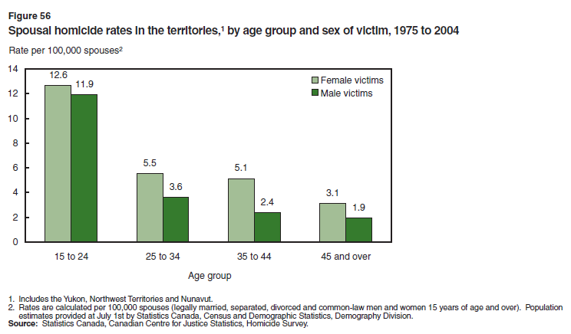
Statistical Profile, which introduced a number of violence indicators. It expands on these indicators, organizing them into five central themes: prevalence and severity; impact; risk factors for violence; institutional and community-based responses; and victims' use of services.

Although the majority of the data have previously been released, the report provides new information on violence against women in the three territories.
For the first time, as part of a pilot study, the 2004 General Social Survey (GSS) on
Victimization interviewed women and men in the three territories about their experiences with respect to spousal violence, in addition to other crimes.

The GSS showed that women in the territories report higher rates of spousal violence than those living in the provinces. Police statistics also indicate that women in the territories also experience higher levels of sexual assault and homicide.
According to the GSS, spousal violence in the territories came to the attention of the police more often than violence occurring in other parts of Canada. In addition, the use of shelters in the territories is the highest in the country.

Overall, 12% of adult residents of the three territories who had been married at some point in their life, or who had lived in a common-law relationship, had experienced violence by a spousal partner in the five years prior to the survey. This compares with 7% in the provinces.

Police data show that rates of homicide in the territories are the highest in the country and that rates of sexual assault are also higher than in the provinces, although rates of sexual assault have declined in all three territories in recent years.

During the past few months, Statistics Canada has released several reports which have contained data on the nature and extent of spousal violence, criminal harassment and many other acts of violence against women.

This new report puts these data into perspective, and provides a snapshot of violence against women in Canada.

Findings from the report show that women are more likely than men to be the victims of the most severe forms of spousal assault, as well as spousal homicide, sexual assault and stalking.

The rate of spousal homicide has also declined in recent years for both women and men, and survey data suggest that the severity of non-lethal assaults against women has also declined somewhat.

Trends in various types of violence against women, as recorded in police statistics, are mixed. Rates of reported sexual assault have declined since 1993. In addition, the number of spousal violence incidents against women has declined since 2000, while the rate of violence perpetrated by boyfriends has increased. Also, the number of male partners reported to police for criminal harassment has risen.

Sexual assault is one of the most under-reported crimes. According to the GSS, fewer than 10% of sexual assaults in both survey years were reported to the police. Police statistics show a decline in sexual assault rates which was most dramatic in the early 1990s. However, it is difficult to know to what extent this is affected by changes in victims' reporting behaviour over time.

Victims' decisions to report the violence to criminal justice and social services depend on a variety of factors, some of which include fear of the offender, shame and embarrassment, and regional availability of services. The majority of victims of spousal assault and over 90% of sexual assault victims did not seek support from the criminal justice system.

The number of female victims of spousal assault who contacted police or social services remained steady between 1999 and 2004. The number of women accessing shelter services has also been stable in recent years. This does not necessarily represent the need for shelter services, however, as the data show that on a single day there were over 200 women turned away from shelters.

According to police statistics, rates of spousal violence and spousal homicide are higher for Aboriginal women than for non-Aboriginal women or Aboriginal men. The severity and impact of spousal violence are also greater for Aboriginal women.

Rates of sexual assault and other violent crimes are higher on reserves than in other areas of Canada.
(Statistics Canada, http://www.statcan.ca/Daily/English/061002/d061002a.htm, March 25, 2008)

